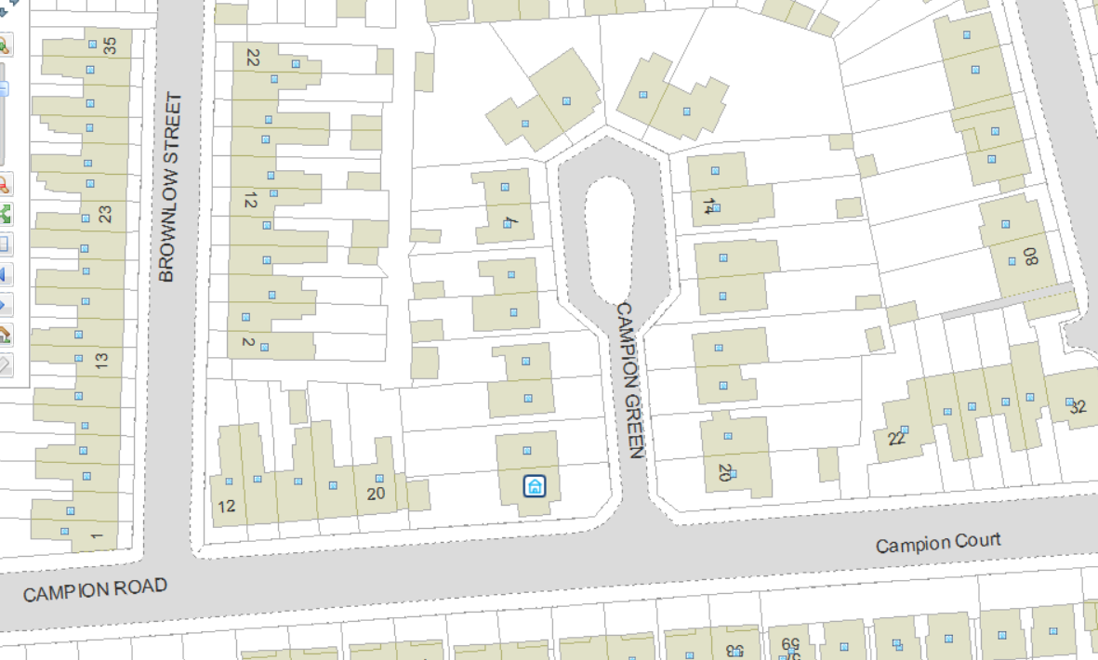
Campion Green Wildflower Verge Trial Area

