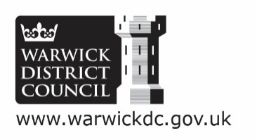

Warwick District Council (WDC) and COMMUNITY INFRASTRUCTURE LEVY

(CIL) Form 5: Notification of Chargeable Development

A CIL Form 5: Notification of Chargeable Development, must be completed and submitted to WDC:

- for a development that involves proposals for a new dwelling (either through conversion or new build) regardless of size,
or
- the establishment of additional residential floorspace (including extensions and annexes) of 100sqm or above; where this development is permitted under a ‘General Consent’ or Permitted Development Rights.

The CIL Form 5 is required for permitted developments only. Applications granted for full planning applications will have been required to complete and submit a CIL Form 1: Additional Information as part of WDC’s validation process.

Failure to complete and submit CIL Form 5: Notification of Chargeable Development to WDC prior to the commencement of development may result in surcharges being incurred. It may also cause problems when selling land or buildings at a later date. This surcharge would be in addition to a surcharge for failing to submit CIL Form 6: Commencement Notice for a development.

CIL Form 5: Notification of Chargeable Development will enable WDC to establish whether or not a development is liable to make a CIL contribution, and if so to calculate the liability accurately, based on the information provided. Inaccurate answers within the CIL Form could result in a CIL liability that is higher than it needs to be, and in some cases may lead to surcharges being imposed.

The CIL levy rate applies to all residential floorspace (including ancillary buildings such as garages/home offices/gyms/pools etc.); these are considered use class C3. CIL liability is calculated based on the gross internal area (GIA) of the ‘development for which planning permission is granted’ (CIL Regulations 40 and 9). This is the proposed floorspace of a development before the consideration of any deductions for existing floorspace that is to be converted or demolished. If your scheme is liable, this charge is payable on commencement of development, unless an exemption is agreed prior to commencement.

Please Note: it is the responsibility of the liable party to understand and comply with the CIL Regulations, including any eligibility for relief. WDC can only assess potential CIL liability based on the information provided by an applicant / agent.

Further information on CIL and all relevant forms can be found on the Council’s website at:
Warwick District Council CIL web pages.

