Business and Planning Act 2020

PUBLIC NOTICE

WAF WAF WAFFLE , is applying for the new grant of a Pavement Licence under Section 2 of the Business and Planning Act 2020.
An application was submitted to Warwick District Council on 07/06/2022 for:
[WAF WAF WAFFLE , 75 WARWICK STREET , CV324RR , LEAMINGTON SPA]

The application is for: [brief description of application (e.g outdoor seating to the front of the premises for serving of food and drink)].

Any person wishing to make representations to this application may do so by writing to the Licensing Authority by no later than: [last date for representations being the date 5 working days after the date the application is submitted to the local authority (excluding public holidays)].
Warwick District Council
Licensing
Riverside House
Milverton Hill
Royal Leamington Spa
Warwickshire CV32 5HZ
licensing@warwickdc.gov.uk

The application and information submitted with it can be viewed on the Council’s website: www.warwickdc.gov.uk
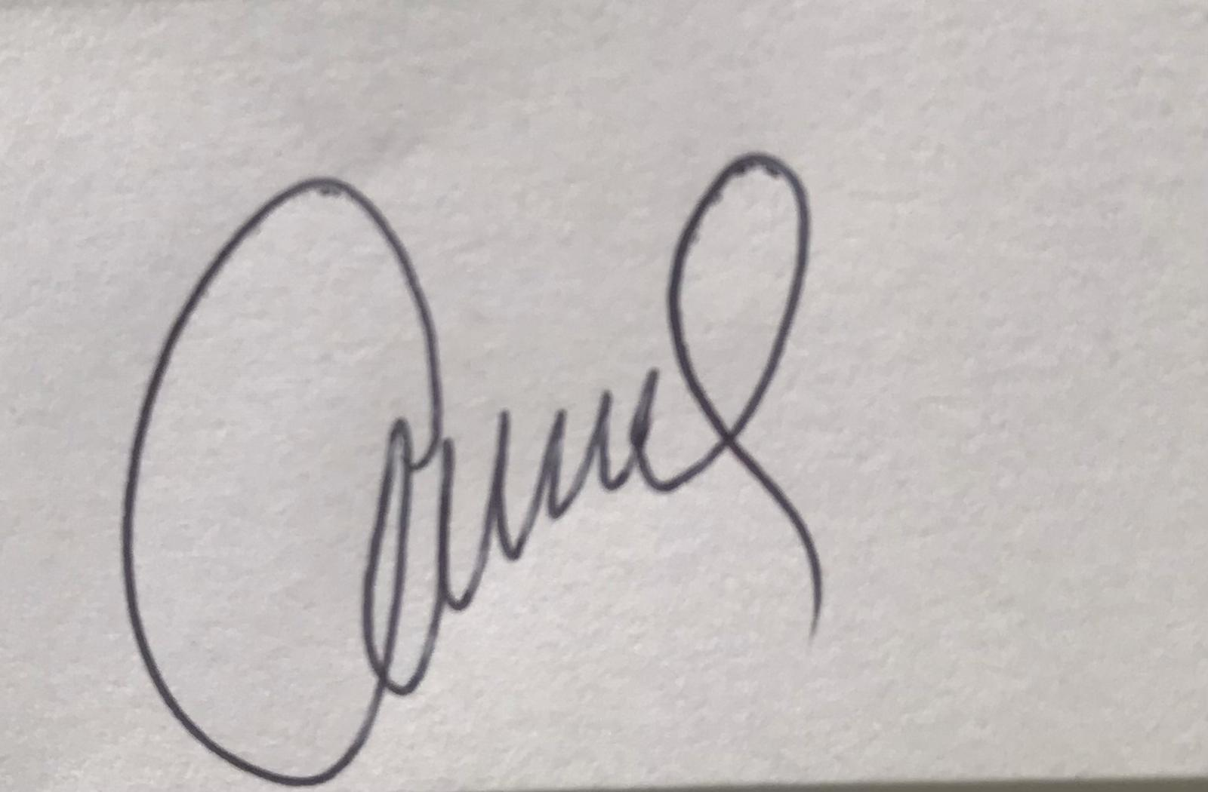
Signed ......................................................................

Dated .............07/06/2022.......................................................

