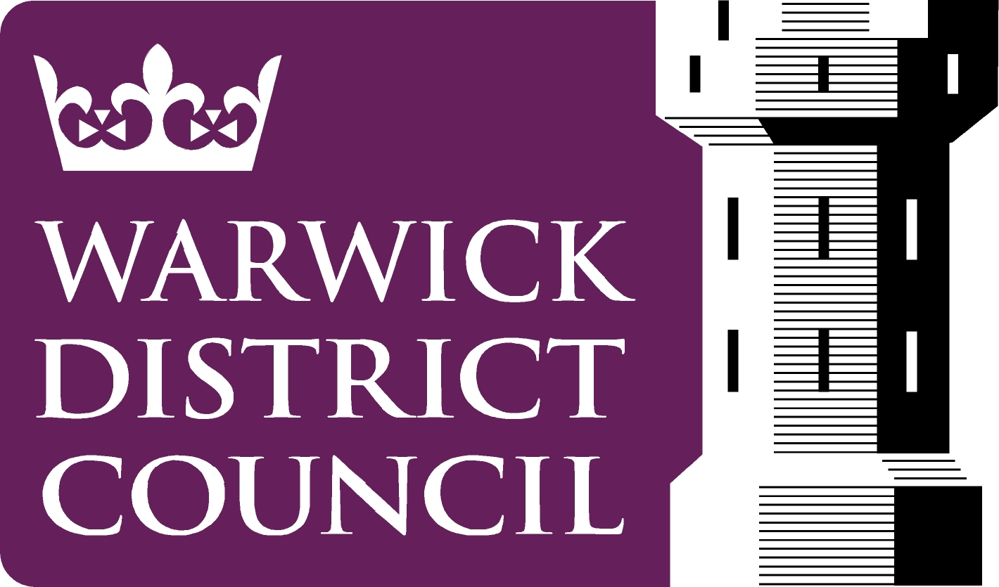 | STREET COLLECTIONS  Application form

Application form for permission to collect money or sell articles in streets or public places within the Warwick District for the benefit of charitable or other purposes.

Section 1

Name of Society, Committee or other organization responsible for the collection

Address (this should be the address of the Head Office of the Society or other body etc.)

Email Address

Telephone number

Section 2

Name of the person making the application for the permit, who will be responsible for the collection

Home Address (including Postcode) note: this is the address that will appear on the permit

Position in above Society

Date of Birth

Email Address

Telephone number

Section 3

Relationship between Charity and person making the application

PLEASE NOTE: If the relationship is one of ‘Professional Fundraiser’ please supply a copy of contract or agreement between the applicant body and the charity.

PLEASE NOTE: If you intend to collect on behalf of a charity of which you are not a member, written authority MUST be obtained from the said charity authorizing you to organize collections on the charity’s behalf and submitted with this application.

Section 4

Name of the Charity or Fund which is to benefit

Registered Charity Number

Address of the Administrative Centre of the fund (i.e. Local Centre)

Name of the Secretary

Telephone number

Objectives of the Charity/Fund

Section 5

Desired collection date

Alternative date(s)

Desired location for collection
(indicate preference with 1st, 2nd, 3rd etc.)

Leamington Spa

Warwick

Kenilworth

Rural/Other – please specify

Disposal of the receipts. Are the whole of the receipts to be paid over for the benefit of the Charity or Fund, or will any deductions be made for expenses, or other purposes?

If any deduction is made, state for what purpose and give an estimate of the sum which will be deducted

Section 6

Has the Society, Charity or person making this application ever had a street collection permit refused or revoked?

If yes, please give details

Section 7

Please indicate whether you intend to have volunteers or paid collectors carrying out the collection

If collectors are to be paid, please give payment details

Please supply details of collectors in table below (Use separate sheet if necessary) (maximum of six collectors)

Full Name | Date of Birth |  | Address
Have any of the collectors ever been convicted of offences involving dishonesty?

If the answer to the above question is yes, please provide full details (use a separate sheet if necessary)

Section 8

Name and Full Address of Accountant

Details of accountant’s qualifications

Section 9

Signature of person making this application

Date of application

False or misleading information given will lead to the application being rejected, and may also result in prosecution.

If your application is granted, please note that you will be subject to the attached regulations.

Please note: There are usually more applications than dates available and it might not be possible to grant all applications.

Once this form is fully completed, return it to:

Licensing Team
Safer Communities, Leisure and Environment
Warwick District Council
Riverside House
Milverton Hill
Royal Leamington Spa
CV32 5HZ.

Licensing@warwickdc.gov.uk

